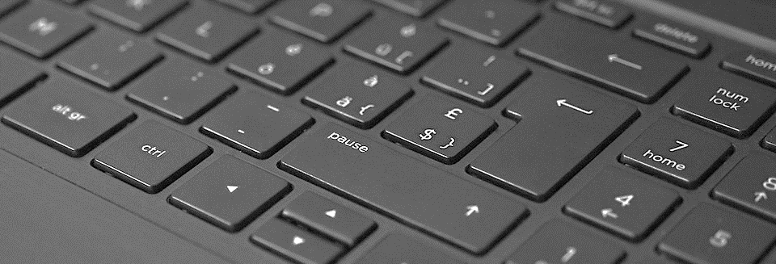

**Assistive Technology for Diverse Learners - FAQ**

***Sunnyside Middle School***

***December 2023***

***Frequently Asked Questions***

**Will students be able to use the technology at home?**

Yes, students can use some technology at home. iPads and speech tablets will be distributed to students and returned at the end of the school year. Unfortunately, C-Pens cannot go home. Parents are welcome to purchase C-Pens and use them at home. (C-Pen: [Click Here](https://www.amazon.com/Pen-Text-Speech-Exam-Reader/dp/B0BLVW58KL/ref=asc_df_B0BLVW58KL/?tag=hyprod-20&linkCode=df0&hvadid=533237102357&hvpos=&hvnetw=g&hvrand=12070691673651688907&hvpone=&hvptwo=&hvqmt=&hvdev=c&hvdvcmdl=&hvlocint=&hvlocphy=9021475&hvtargid=pla-1929749669648&psc=1))

**How can I connect the device to my home network?**

iPads and speech tablets can connect to your home network through Wi-Fi. There is multi-factor authentication on each device; this requires each student to have an email address connected to the device before logging into a home network. Devices should not be connected to public networks for any reason.

**Will there be additional training in the future?**

Yes, the IT professional at Sunnyside Middle School will provide additional training to those who request it. You can email him at [nedstark@sunnyside.edu](mailto:nedstark@sunnyside.edu) for further information. Students can visit during their study hall periods if they need extra support.

**Can I access the training material?**

Yes. All training materials can be found on the school website. There was also an email sent out to all attendees that has all the training slides and documents. If you have trouble accessing the documents, reach out to the IT professional at [nedstark@sunnyside.edu](mailto:nedstark@sunnyside.edu).

**Will this technology have to be approved each year?**

No, this technology will be able to be used without another school board vote. The board will only have to vote on upgrades or new technologies in the future.

**Can students turn down technology use?**

Yes. Although it is not recommended, students can choose to decline using the technology. If students decline C-Pens, the pens may get registered to another student. If this happens, students cannot change their mind and choose to use the C-Pen